Systems
Design
Report

Team Name: ABC (VT-G4-3)
Team Members:
- Jack Temple
- Leon Brown
- Abhishek Reddy Nagella
- Daniel Cyril Obon
- Zaid Sadeq
- Benjamin Travor Ssettuba

Contents
1 Introduction 1
2 Team Roles 1
2.1 Benjamin Travor Ssettuba 1
2.2 Daniel Cyril Obon 1
2.3 Leon Brown 1
2.4 Jack Temple 1
2.5 Abhishek Reddy Nagella 2
2.6 Zaid Sadeq 2
3 Requirement 1: login and registration 3
3.1 User Story 3
3.2 Wireframe 3
3.3 Use Case Diagram 4
3.4 Sequence Diagram 4
3.5 Class Diagram 5
3.6 Entity Relationship Diagram 5
4 Requirement 2: Main interface 1 7
4.1 User Story 7
4.2 Wireframe 8
4.3 Use Case Diagram 9
4.4 Sequence Diagram 10
4.5 Class Diagram 11
4.6 Entity Relationship Diagram 12
5 Requirement 3: Main interface 2 14
5.1 User Story 14
5.2 Wireframe 14
5.3 Use Case Diagram 15
5.4 Sequence Diagram 16
5.5 Class Diagram 16
5.6 Entity Relationship Diagram 17
6 Requirement 4: checkout 18
6.1 User Story 18
6.2 Wireframe 18
6.3 Use Case Diagram 19
6.4 Sequence Diagram 19
6.5 Class Diagram 20
6.6 Entity Relationship Diagram 21
7 Requirement 5: payment 22
7.1 User Story 22
7.2 Wireframe 22
7.3 Use Case Diagram 23
7.4 Sequence Diagram 24
7.5 Class Diagram 24
7.6 Entity Relationship Diagram 25
8 Requirement 6: delivery 27
8.1 User Story 27
8.2 Wireframe 27
8.3 Use Case Diagram 28
8.4 Sequence Diagram 29
8.5 Class Diagram 30
8.6 Entity Relationship Diagram 30
9 Sustainability Statement 32
10 Equality, Diversity and Inclusion Statement 32
11 Peer Assessment 32
11.1 Jack Temple 32
11.2 Leon Brown 32
11.3 Abhishek Reddy Nagella 32
11.4 Daniel Cyril Obon 33
11.5 Zaid Sadeq 33
11.6 Benjamin Trevor Ssettuba 33

Introduction
This report provides an overview of selected requirements for the new web site.

Team Roles

Benjamin Travor Ssettuba
Name: Benjamin Travor Ssettuba
Team member role – Registration and Login manager
Duty – Supporting the system as a registration and login manager with a main focus on data entry from the users for login and registration purposes with emphasis on security of the provided data .

Daniel Cyril Obon
Background and skills: BCS (Hons) Information Technology, supporting the team as a site designer with focus on one part of the main interface, specifically the search functions, notifications/messages, banners, category sorting and ‘my eBay’ profile tab. 5-year experience in site designing such as collaborating in the creation of the main UI of Teesside Online site for Teesside University and responsible for its upkeep.
Roll= Interface designer 1

Leon Brown
I’m Leon Brown, I’m working on the User Interface area of the ebay website, primarily focusing on specific product descriptions and related items search. I made 2 wireframes each for their respective, aforementioned areas and used the ebay website as a reference. All of the work/subjects was completed on Diagrams.net excluding the User stories, and
should cover everything. When designing the Wireframes I made use of the Database design and web development skills I had picked up from previous lessons and put them into use, and with having a previous knowledge of computer science, I felt I had an easier time picking up and implementing these skills. Overall, the final result should reflect the task given to me and fulfil the subject criteria.
Roll= Interface designer 2

Jack Temple
Name = Jack Temple
Roll = checkout designer
Background = I have a background in computer science which comes from having an A-level in the subject. This means that I’ve done projects with similar requirements to my ICA.
Skills =
- prior experience designing similar diagrams such as wireframes and case diagrams.
- Experience with draw.io

Abhishek Reddy Nagella
NAME : ABHISHEK REDDY NAGELLA
TEAM MEMBER ROLE : PAYMENT SERVICE AUTHENTICATOR
EMAIL : W9593375@live.tees.ac.uk
Skills : -
Good at wireframe designing
Quick learners

Zaid Sadeq
I’m Zaid Sadeq. I'm taking on the responsibility of customer dispatch interactions and aftercare, I used a multitude of diagrams to take on this task from wireframes to ERDs detailing the required designs both functional and non-functional. I used my skill in computer science and IT to help me approach the problem professionally and concisely, I needed to apply my database design and app design skills to complete this task
Roll= dispatch designer

Requirement 1: login and registration
Functional
R1= The ECP shall allow a customer to register with the site
R2= The ECP shall use the customer’s email ad- dress as the username for logon purposes.
R3= The ECP shall require the customer to set a password.
R4= The ECP shall allow customers to view and edit their customer information.
R5= The ECP shall collect customer information consisting of name, address, email address, phone number, fax number, credit card information.
Non-functional
R1= The ECP shall be available 24 hours per day, 365 days per year.
R2= The ECP shall log in a customer within 5 seconds.
R3= The ECP shall support 10,000 concurrent sessions.

User Story
Functional requirements
- As an account manager I want the customers to be able to register with the site so that I can easily administer the participants.
- As the account manager I want the system to use the customer’s email addresses as the username for logon purposes so that I can uniquely identify each customer.
- As a customer I want the system to require me to set a password so that I can ensure security of my data.
- As a customer I want the system to allow me to view and edit my customer information so that I can strengthen the security of my account.
- As the account manager I want the system to collect customer information consisting of name, address, email address, phone number, fax number, credit card information so that I can use it to manage different customers distinctively.

Non-functional requirements
- As a customer I want the system to be available 24 hours per day, 365 days per year so that I can access my account at any time of my convenience.
- As a user I want the system to log me in within 5 seconds so that I can have quick access to my account.
- As the Systems Support manager I want the system to support 10,000 concurrent sessions so that I have a wider coverage of customers at a go.

Wireframe
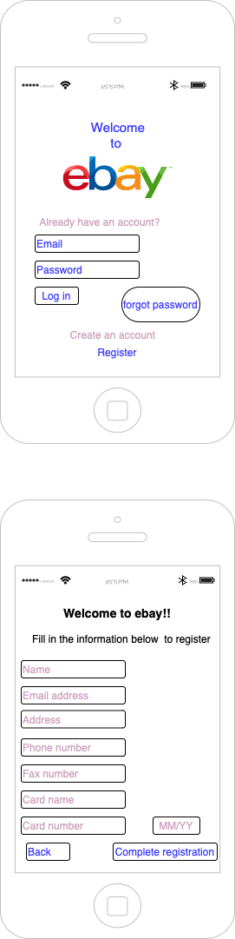

Use Case Diagram
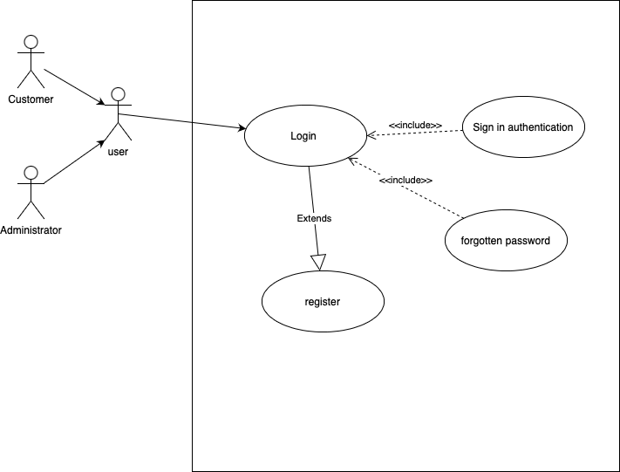

Sequence Diagram
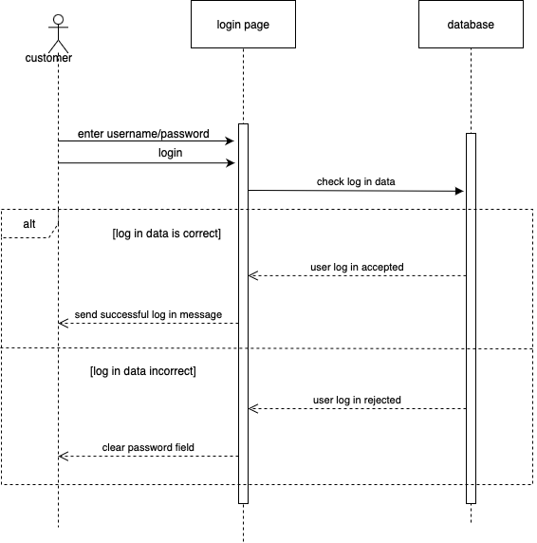

Class Diagram
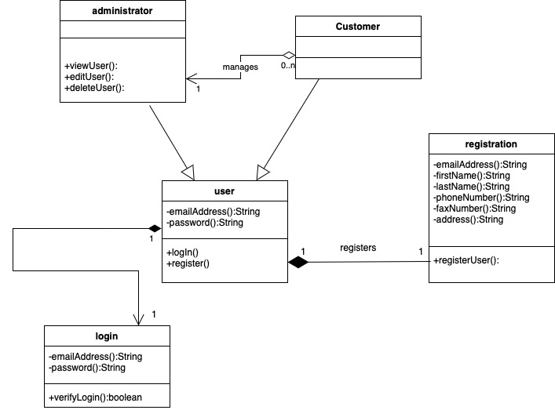

Entity Relationship Diagram
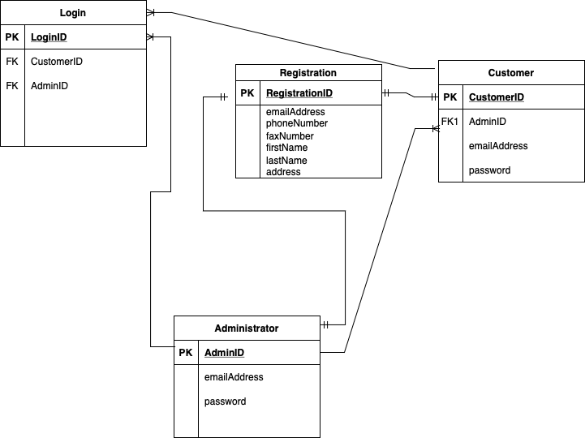

Requirement 2: Main interface 1
Functional Requirement:
1. R25 - The ECP shall allow customers to view and edit their customer information.
2. R2 - The ECP shall organise the list of products by product category.
3. The ECP shall display a banner of current promotions/deals.
4. The ECP shall display allow users to search for items using a search bar.
5. The ECP shall display alerts of messages by seller/the site.
Non-functional Requirement:
1. R30 - The ECP shall be available 24 hours per day, 365 days per year.
2. The ECP shall support most major operating systems.

User Story
Functional Requirements:
- As a site designer, I shall display banners with different types of promotional material/items currently available on the site as it could help in sellers/companies to promote their deals/items by giving a more prominent area on the homepage for greater exposure.

- As a site designer, I shall display notifications/messages to the user from the site/seller as it allows for a more visible display to the user as to lessen the likelihood of users missing important messages/notifications.

- As a site designer, I shall display profile options for the user by clicking the “my eBay” dropdown as it helps users to easily access their profile to make changes or to upkeep their sales on the site.

- As a site designer, I shall display a category sorting option to display specific categories of items as it allows users to easily got through the many items for sale on the site to search for their desired item, and thus allows for further narrowing down of the user’s search for an item.

- As a site designer, I shall implement a search bar as it helps in greatly reducing the time it takes to search for a specific item to be displayed to the user on their search, which in turn improves the user experience.

Non-functional Requirements:
- As a site designer, the site shall be available 24/7 as it allows users to access the site regardless of time zone differences, making the site more reliable.

- As a site designer, the site shall be able to run on all major operating systems to accommodate as many users as possible from different electronics mediums, thus improving the reach of the site.

Wireframe

Figure 1: Homepage (Main) Interface Wireframe

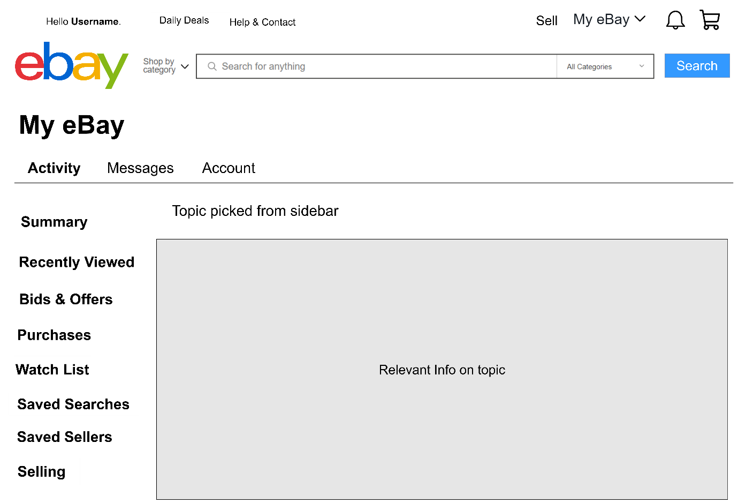
Figure 2: ‘My eBay’ Interface Wireframe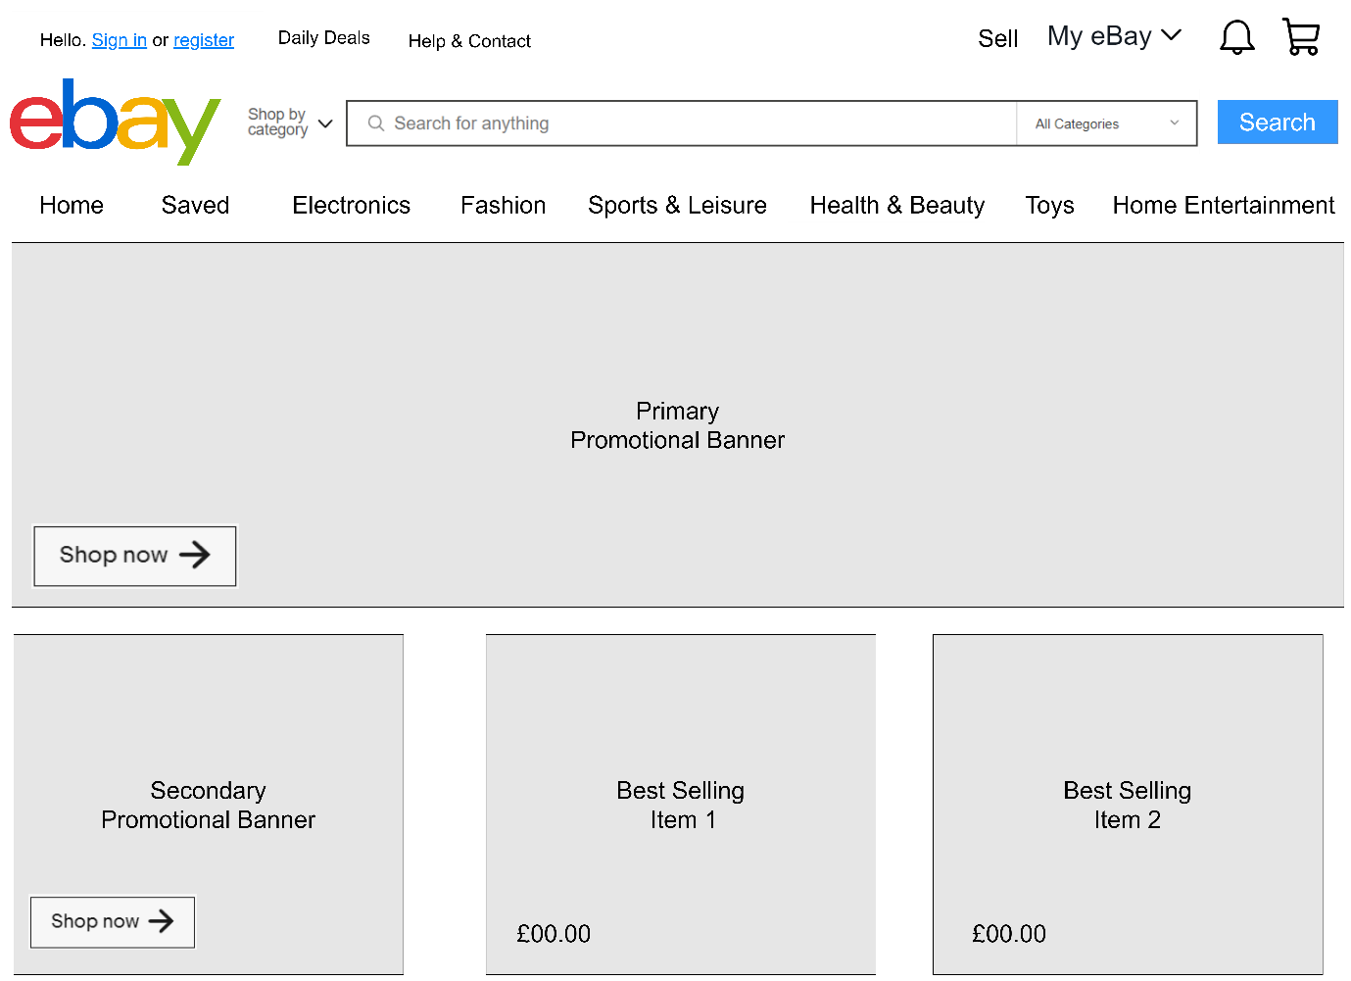

Use Case Diagram
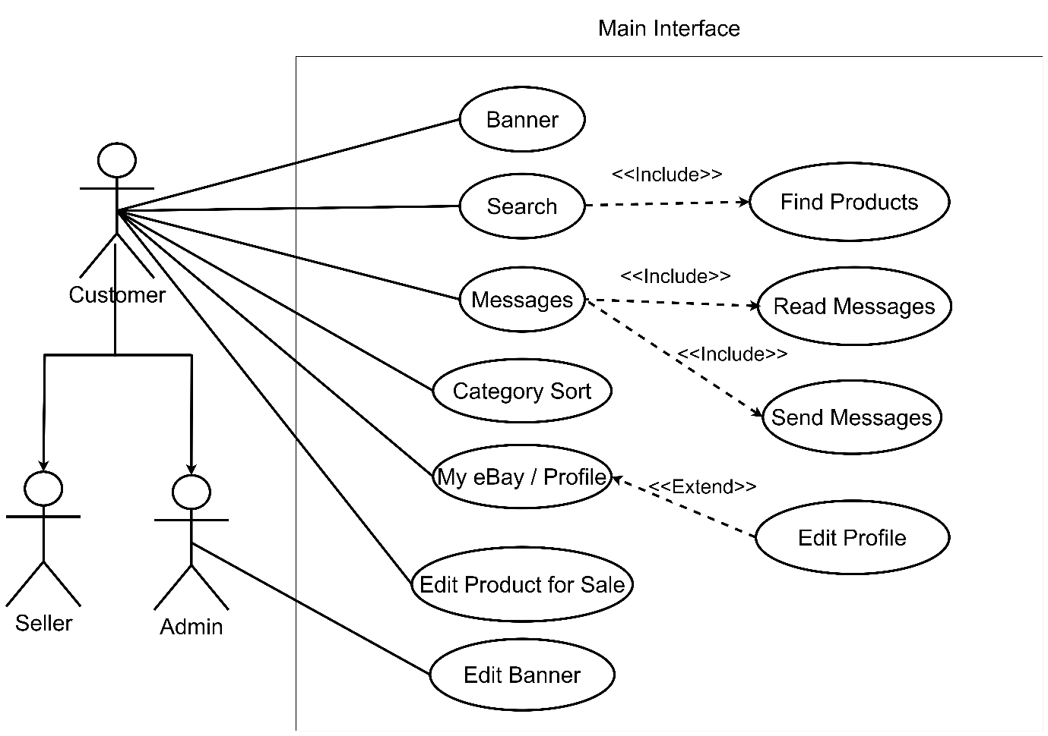

Sequence Diagram
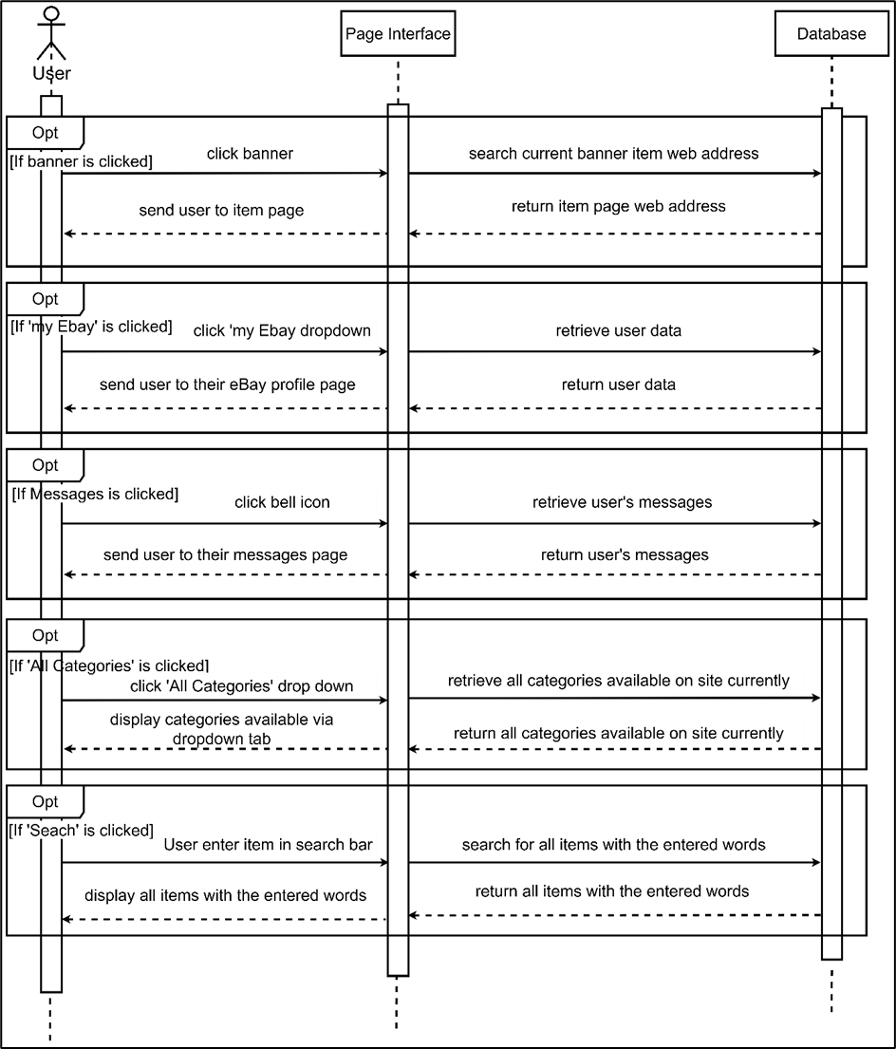

Class Diagram
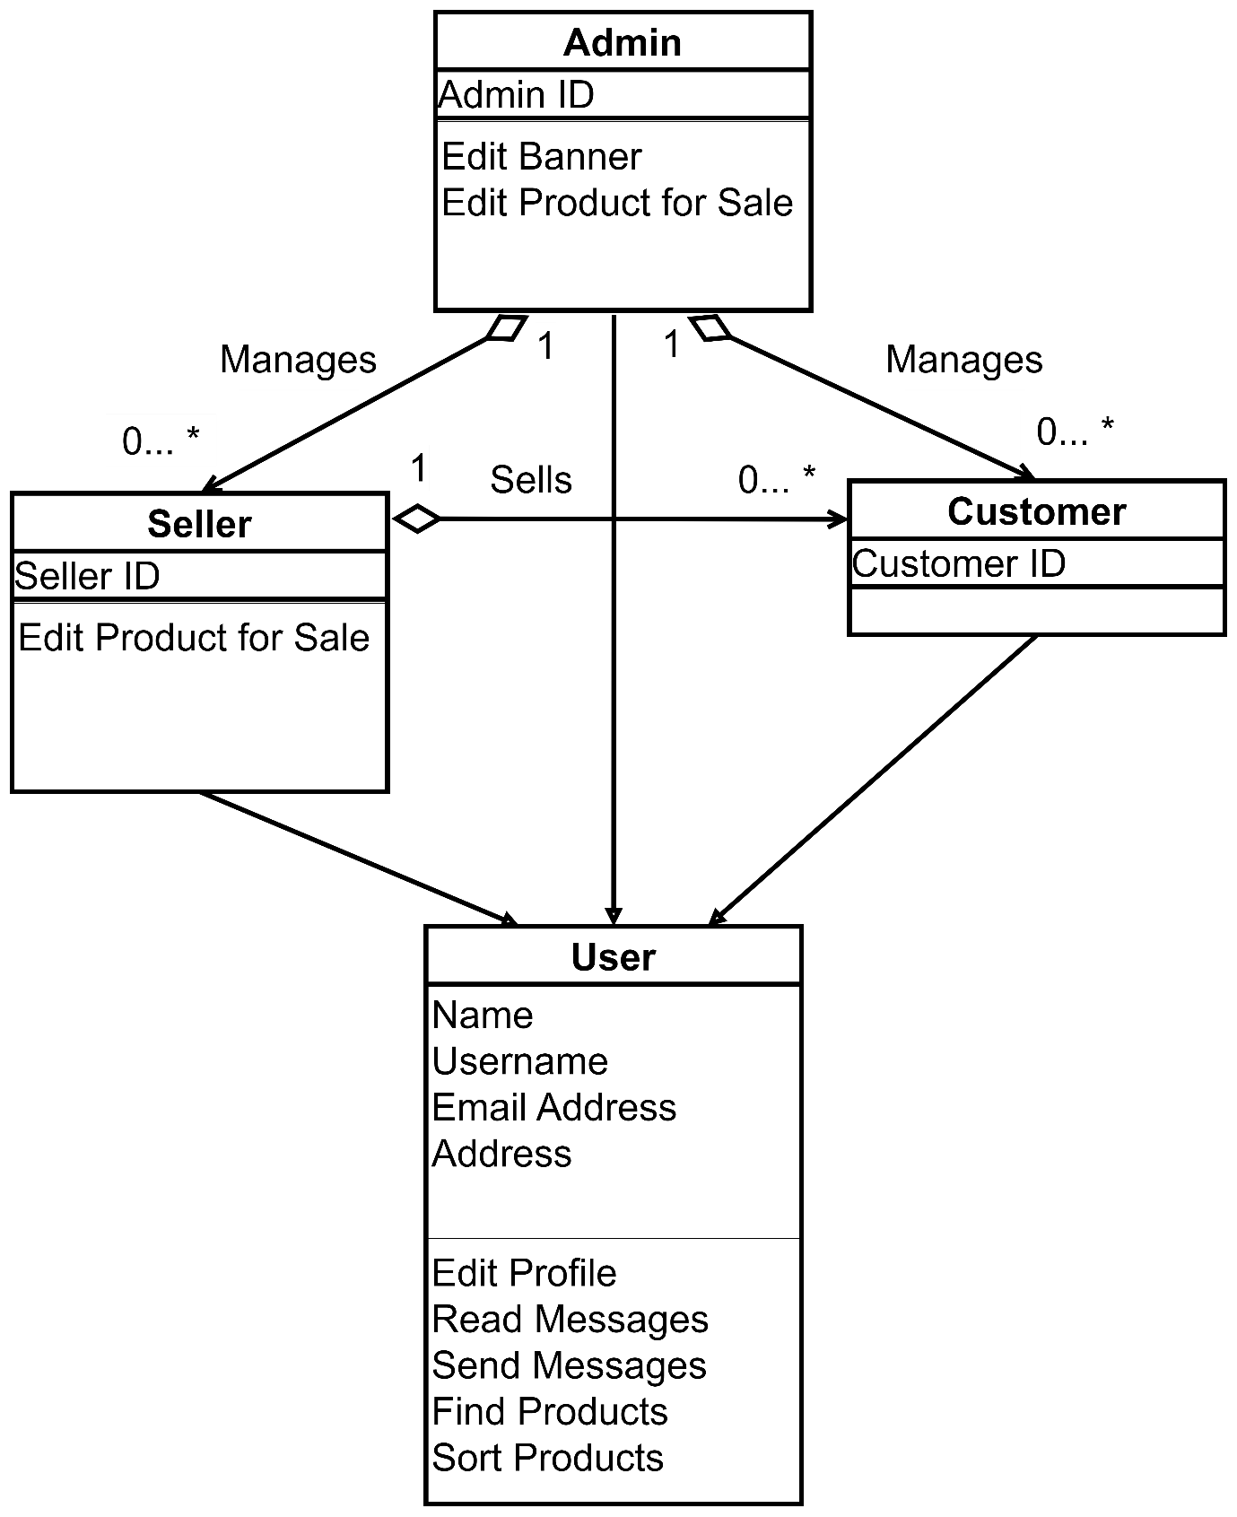

Entity Relationship Diagram
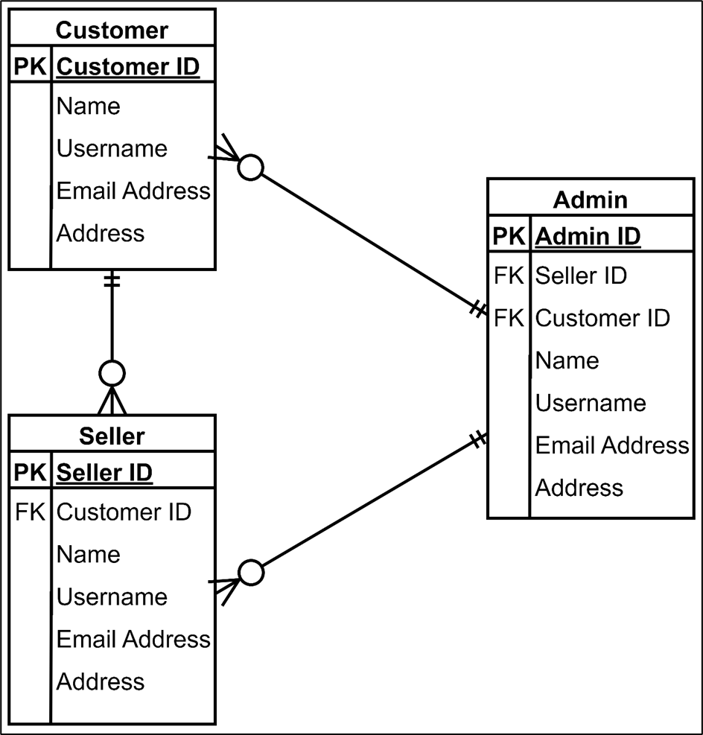

Requirement 3: Main interface 2
R1= The ECP shall display a list of all products offered by ebay
R(self made)= The ECP shall display of list of related items when selecting a product.
R3= The ECP shall display detailed product descriptions consisting of name, photograph, price and description on demand.
R4= The ECP shall display the number of items currently in the shopping basket on each page of the catalogue.
R9/10= The ECP shall allow the customer to place items into a shopping basket.
Non-functional
R12= The ECP user interface shall support the insertion of adverts.
R34= The ECP shall work with the common browsers on popular devices

User Story
Functional requirements
R1- As a customer, I want the ECP to display a list of products offered by the company, so that I can see if I’m interested in buying anything.
R(self made)- As a customer, I want the ECP to display related or similar items to the one I’m looking for, so that I can see alternatives I may not have previously thought of.
R3- As a customer, I want the ECP to display a detailed product description on demand, so that I can clearly see the attributes of what I’m purchasing.
R4- As a customer, I want the ECP to display a list of item currently in the shopping basket on each page of the catalogue, so that i can keep track of how many items are currently on hold for buying
R9 & R10- As a customer, I want the ECP to allow me to place and remove items in the shopping basket, so that I can manage my basket easily.
Non-Functional requirements
R12- As a user, I want the system to support various features, so that new ads can easily be inserted into the future.
R34- As a user, I want the system to be easily adaptable, so that it can run on common browsers and popular devices.

Wireframe
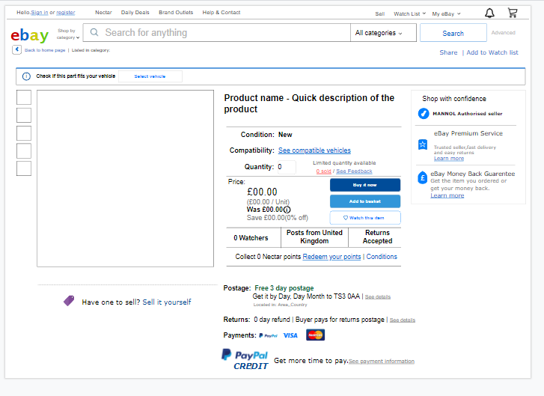
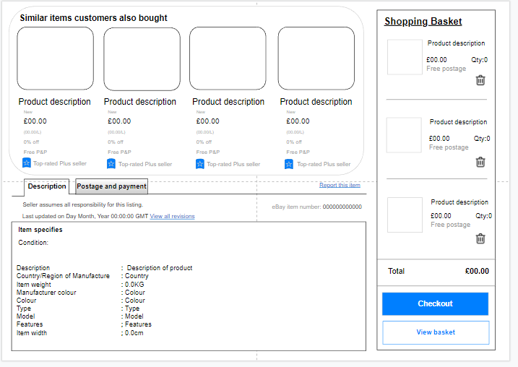

Use Case Diagram
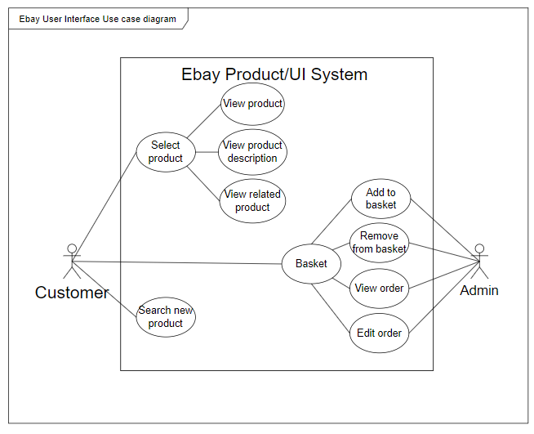

Sequence Diagram
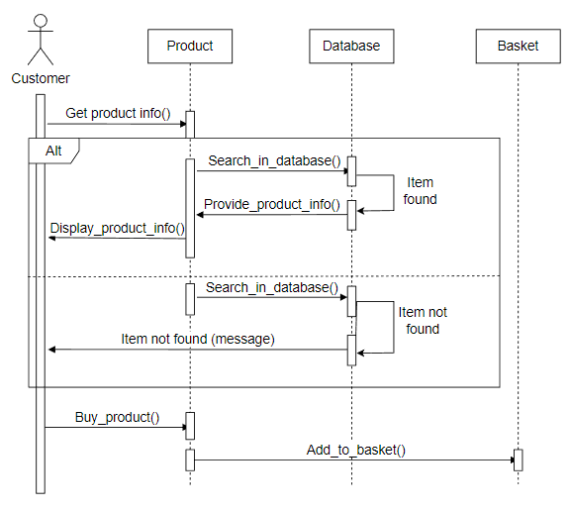

Class Diagram
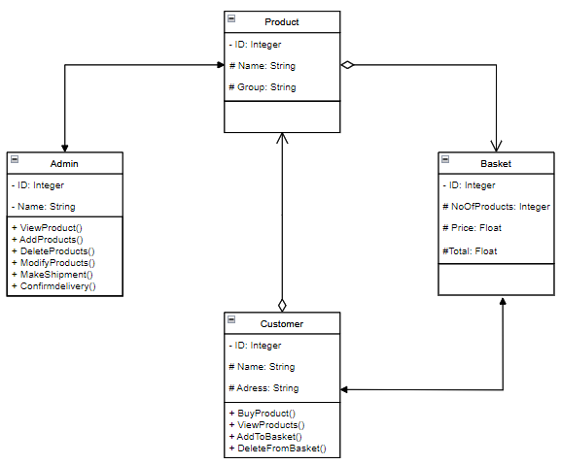

Entity Relationship Diagram
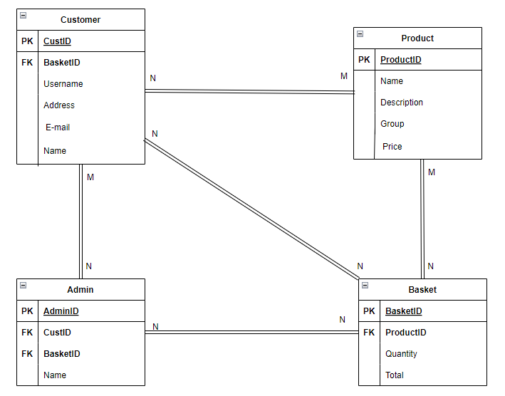

Requirement 4: checkout
functional
R9= The ECP shall allow the customer to place items into a shopping basket.
R10= The ECP shall allow the customer to remove items from their shopping basket.
R11= The ECP shall allow the customer to “check out” and pay for their products.
R16= The ECP shall allow the user to save items without putting them into the basket
R(self made)= The ECP shall allow the user to save items without putting them into the basket
Non-functional
R(self made)= The ECP shall load the basket to be viewed in 5 seconds or less 95% of the time
R(self made)= The ECP shall load all of the items in the basket to show the user

User Story
Functional
The ECP shall allow the customer to place items into a shopping basket. | as a customer I want to have all of my desired items in one place so that I can buy them all at once.
The ECP shall allow the customer to remove items from their shopping basket. | as a customer I want to be able to remove items from my basket so that I can change my mind on what items I wish to buy.
The ECP shall allow the customer to “check out” and pay for their products. | as a designer I want the users to be able to go to checkout and pay for their items so that they can finish their transactions.
The ECP shall allow customers to view their order history. | as a user I want to be able to look at my history of transaction so that I can re-order items
The ECP shall allow the user to save items without putting them into the basket | as a user I want to be able to save items with having to pay for them so that I can buy them in the future.
Non-functional
The ECP shall load the basket to be viewed in 5 seconds or less 95% of the time | As a user I would want to be able to quickly ad easily view the items in my basket so that I know I already have saved and what I still need to look for.
The ECP shall load all of the correct items in the basket 95% of the time | as a user I want the website to load all of my desired items to show me so that I know all of the items I plan to purchase.

Wireframe
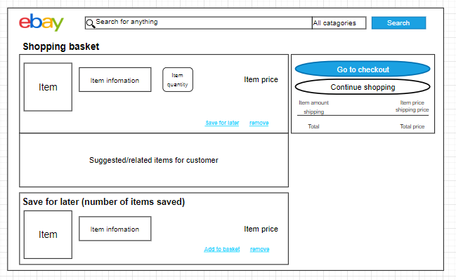

Use Case Diagram
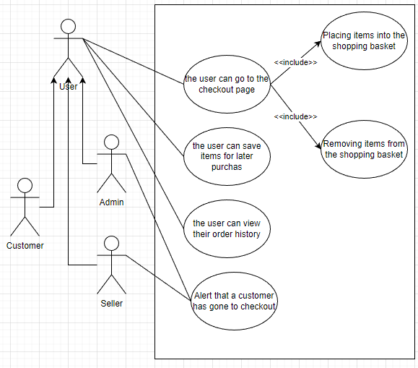

Sequence Diagram
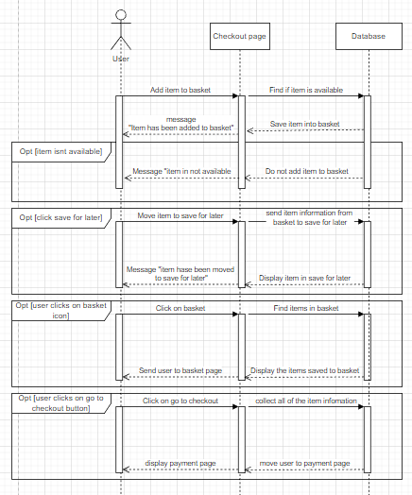

Class Diagram
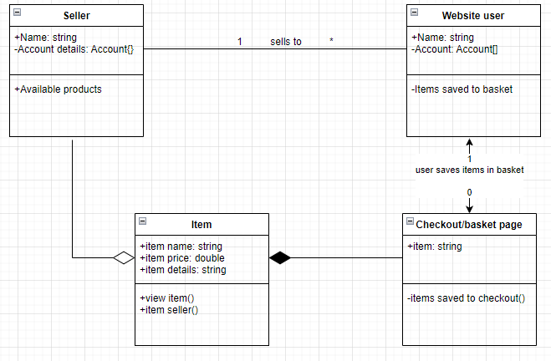

Entity Relationship Diagram
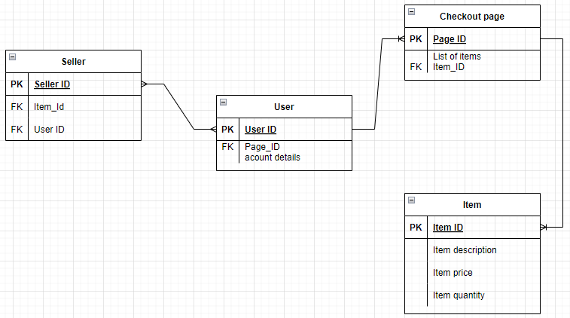

Requirement 5: payment
Functional requirements :
R5 : The ECP shall accept all major credit cards
R6 : The ECP shall validate payment with the credit card processing company
R7 : The ECP shall automatically calculate and add shipping charge to the order
R :The ECP allow the customer to checkout and make a payment to place a order
R : The ECP shall return the payment when customers cancels the order

Non functional requirements :
R : The ECP shall accept payment and raise an order within five seconds in 95 % of the cases
R: The ECP shall support a peak transaction rate of 10 transactions per second

User Story
Functional requirements :
R1 : as a client, I want the system should alllow all credit cards , so that people can make cashless transactions
R2 : Aa a user , I want my payment to be validated with my credit card processing company , so that they can keeps accurate tracking for my purchase
R3 : as a cliengt , I want the system should support to add shipping charges , so that people don’t need to pay them seperately
R4 : as a client , the system should support people to add to checkout so that people can buy them and place an order
R5 : as a client , the system should send a confirmation receipt of payment so that they get know that the payment is successful

Non functional requirements :
R1 : as a client , the system should raise an order quickly , so that people wont take much time to raise an order

R2 : as a client , the system should support peak transaction rate of 10 transactions per second , so that people don’t need much time to get confirmation of their orders and transactions.

Wireframe
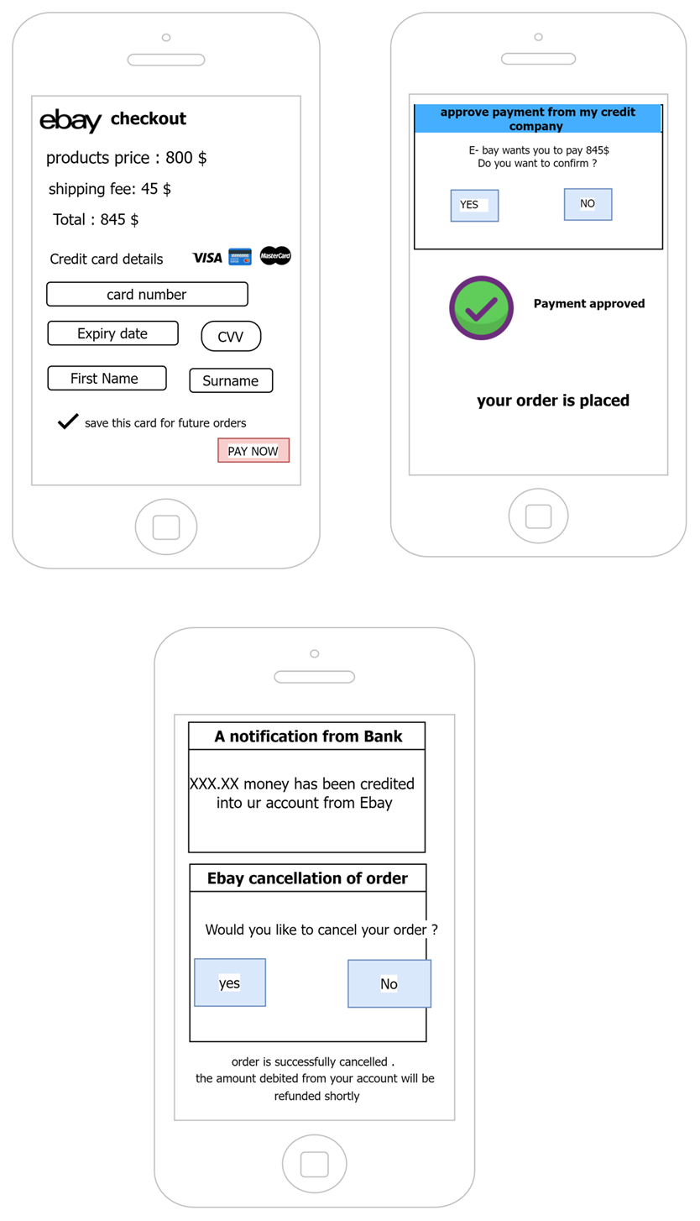

Use Case Diagram
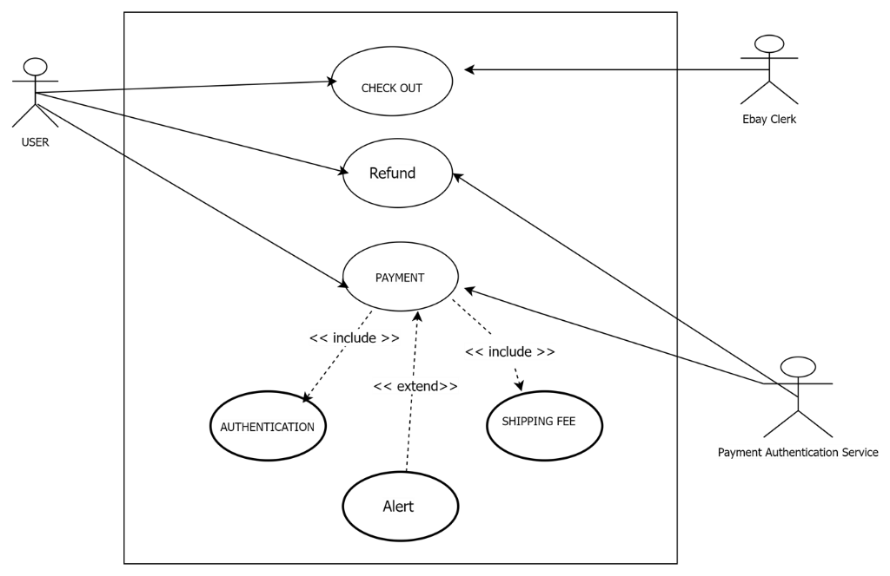

Sequence Diagram
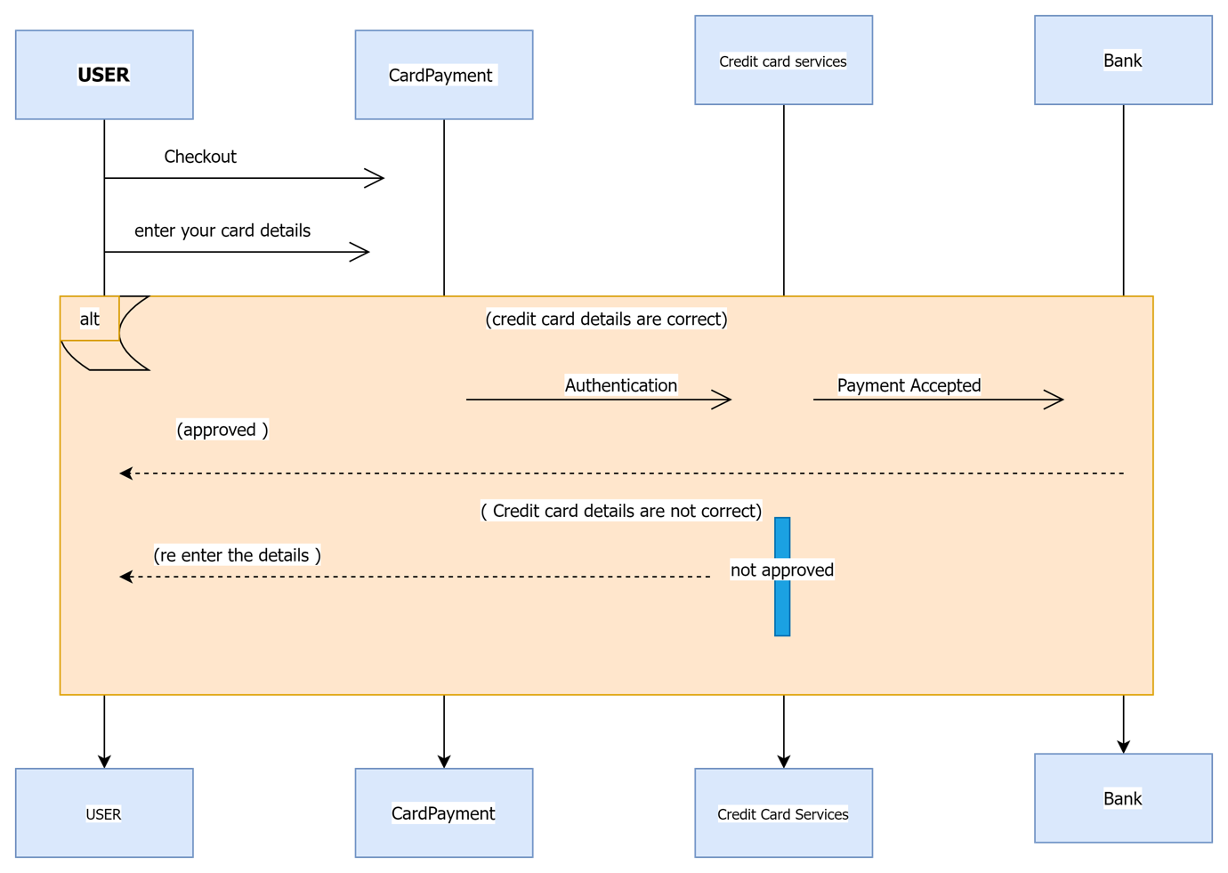

Class Diagram
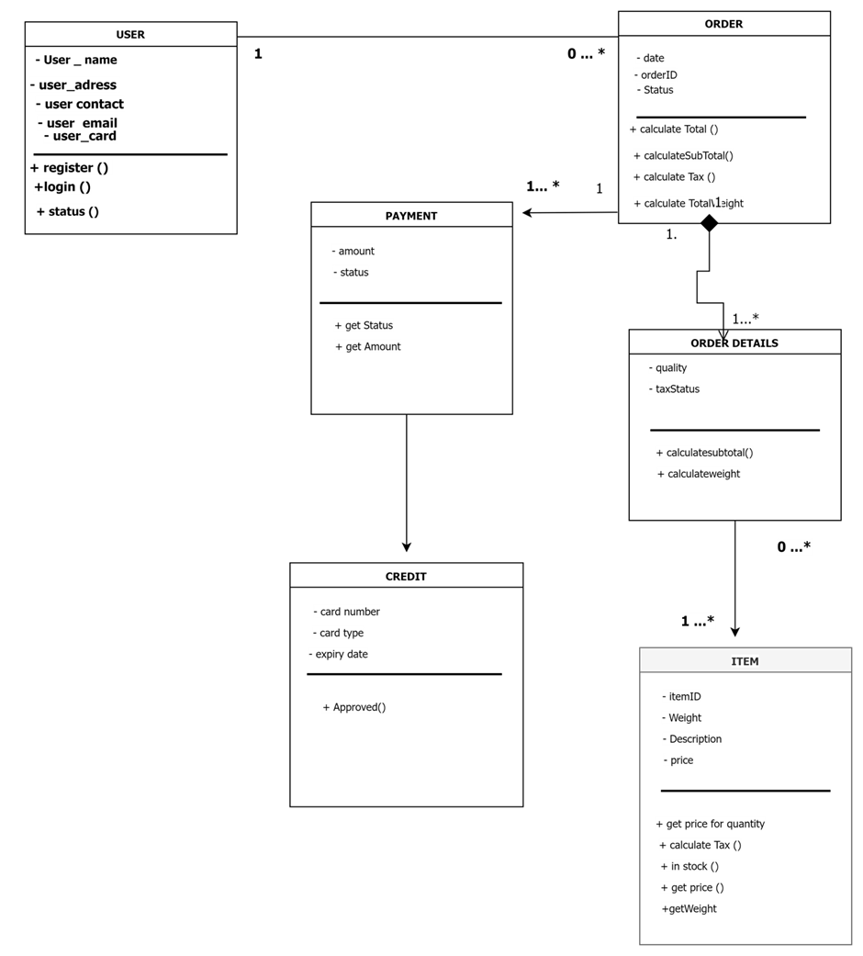

Entity Relationship Diagram
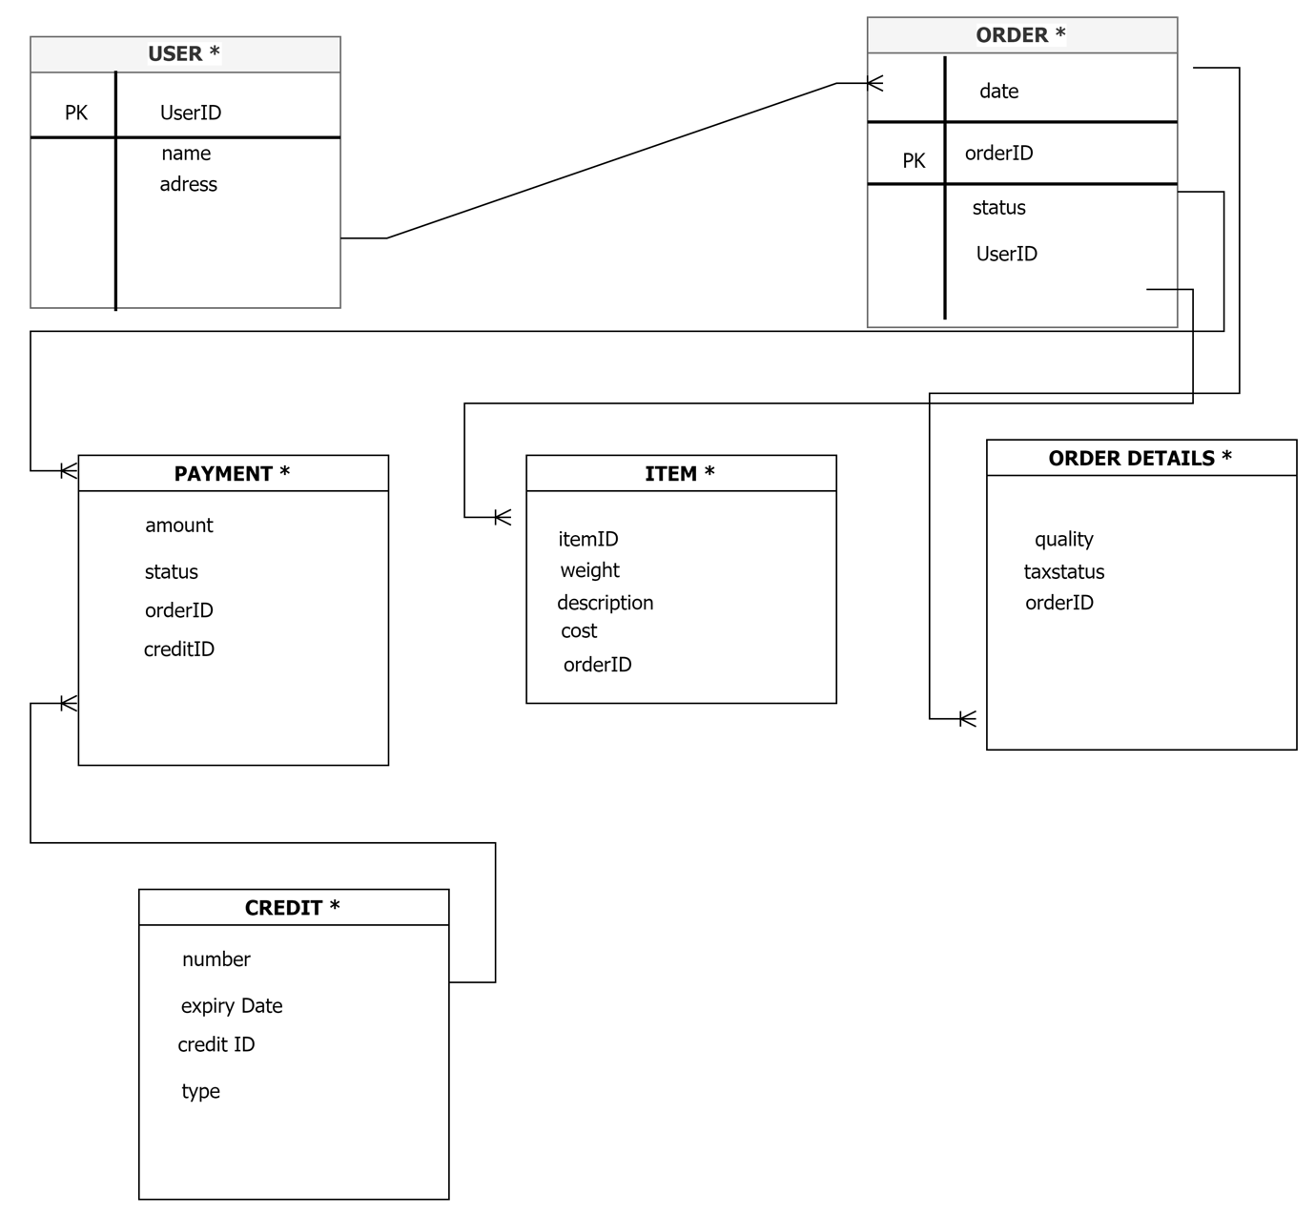

Requirement 6: delivery
R13: The ECP shall raise a new customer order at the point of payment
R14: The ECP shall notify the seller once the order has been paid for
R15: The ECP shall send a copy of the current order to the buyer and seller when the payment is accepted and the order is confirmed
R17: The ECP shall allow a customer to cancel an order provided that the order is accepted and the order confirmed
R18: The ECP shall notify the seller when an order is cancelled
R20: The ECP shall allow the seller to view all orders.
R39: The ECP shall provide a security audit trail

User Story
R13= As an administrator I want to have an organised data entry for new customers so that I can track and manage the ECP activities.
R14= As an administrator I want to notify the seller once the order has been paid so that it could be dispatched and delivered on time
R15= As a customer I want to know when my payment and order is confirmed so that I can know when to expect my order.
R17= As a customer I want the option to cancel an order before it has been dispatched in case I change my mind about the order.
R18= As an Administrator I want to notify the seller when an order is cancelled so that no orders are sent that are not wanted.
R20= As an administrator I want the seller to view all orders so that they know which orders have yet to be fulfilled.
R39= As a site manager I want to have a security audit trail so that if I want to investigate a report, I can track transactions and records.

Wireframe
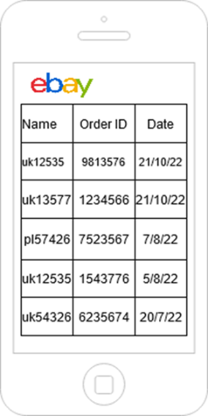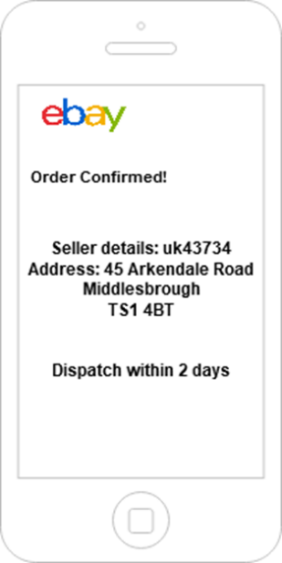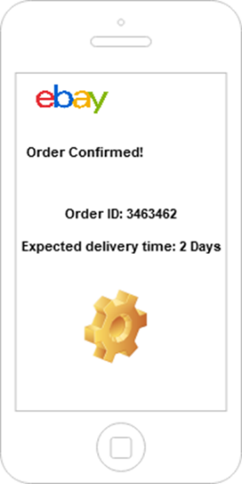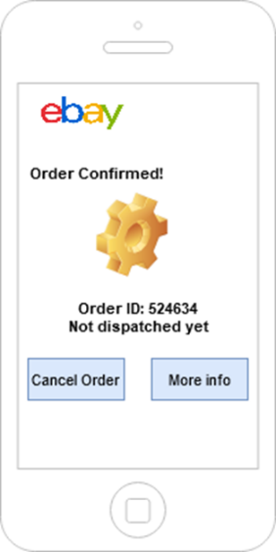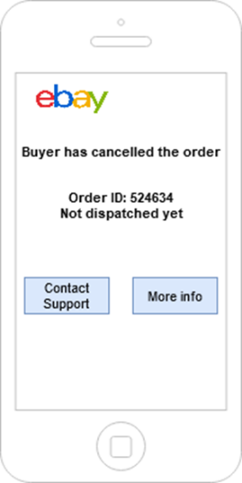

Use Case Diagram
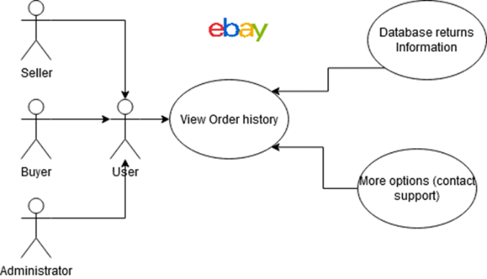
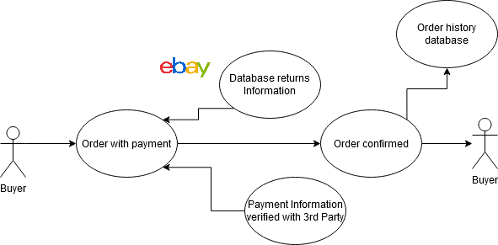
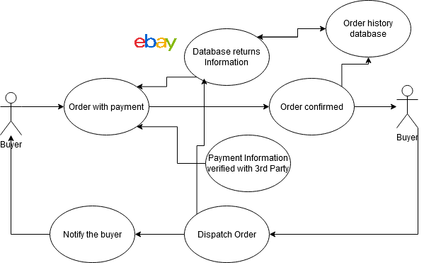

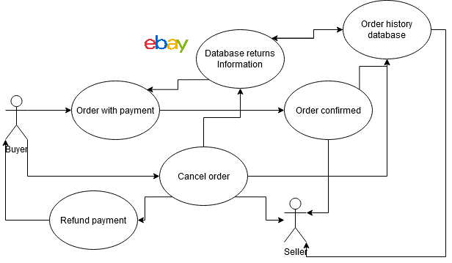

Sequence Diagram
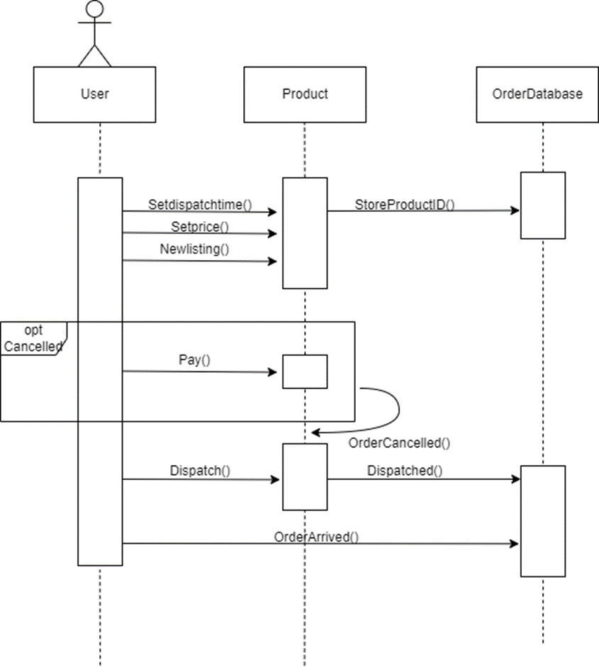

Class Diagram
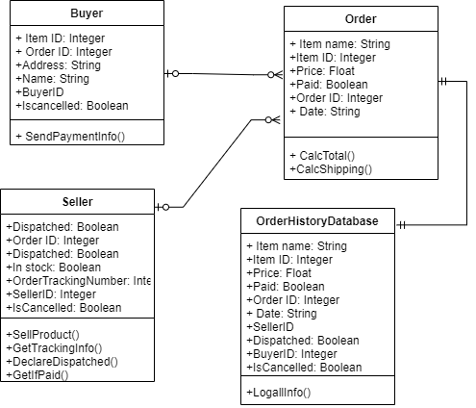

Entity Relationship Diagram
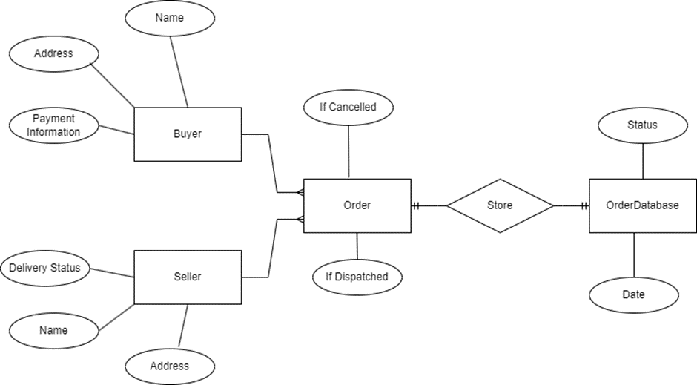

Sustainability Statement
One example of a social impact is that by having such easy access to delivering items directly to the buyer’s door, however, this can be countered in part by the website having a feature that tells the users where they can access these same in their local area. On top of this we are planning to work with more local businesses to give them more customers as well as exposing more people to their products. This will get people to use their local areas more which will also result in the users having the opportunity to go out more.

An environmental impact of out website is that through packaging, shipping, and travel there will inevitably by pollution caused by our website. There are many ways to counter the large potential for pollution such as giving sellers the opportunity to use sustainable and recyclable packaging. Another counter to the pollution problem is to work with shipping companies that have the same idea of reducing pollution.

Equality, Diversity and Inclusion Statement
Our website strives to be inclusive and diverse with its employees and users, we will support this by allowing anyone from anywhere to use the website so that our services do not discriminate against our userbase.

Peer Assessment

Jack Temple
A good group leader, he is always responsible in booking areas for group meetings while also attending all of them. Moreover, he is the one who compiled everyone’s work together into the main group work document. He also makes frequent notifications in Teams to ensure that members are always up to date with group meetings and hand in dates for works.

Leon Brown
Very proactive in contributing during group discussions. He is also very willing to help others with their work by giving valuable feedback. As he is working on the main interface with me, we were able to bounce ideas around each other. However, he is inactive on Teams, making it very hard to confirm his attendance for group meetings as well as communicating with him outside of group meetings.

Abhishek Reddy Nagella
Always responds to messages on Teams, which makes planning for area bookings for group meetings easier. However, he could be a little bit distracting as he would make small talk with group members during group meetings which disrupts the focus as well as the group discussion atmosphere.

Daniel Cyril Obon
I think that I have brough a positive presence during group meetings as well as completing my part of the work in a timely manner. Besides that, I think I have made reasonable contributions in the group discussions. Sadly, due to my lack of technical skills, I would usually ask my group mates questions on certain parts of the assignment as I was not truly sure its criteria. Due to this, it could be said that I might have bothered my colleagues with their work by interrupting their focus.

Zaid Sadeq
Is frequently active on Teams as well as always contributing in group discussions. Besides that, he is also sometimes responsible for booking meeting areas for group meetings when the leader is unavailable. However, he could be a little inconsistent when attending group meetings.

Benjamin Trevor Ssettuba
Is always ready for group meetings as well finishing his part of the work very quickly. However, he is usually quiet during group meetings, which unfortunately leads him to not contribute much during group meetings.

